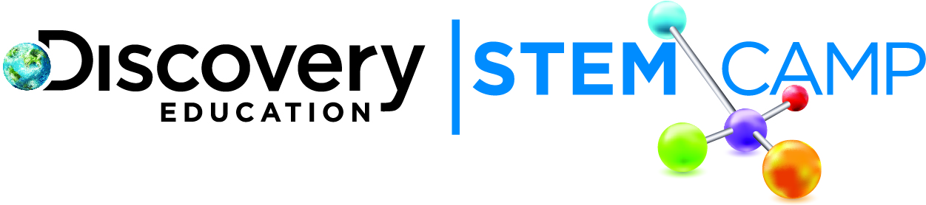

Dear Parents/Guardians,

The third day of Discovery Education STEM Camp was Energetic! Today’s topic was Wind and Solar Energy. We developed a deeper understanding of wind and solar energy as alternatives to fossil fuels. We also learned about the challenges faced using wind and solar energy and discussed ways to address some of these challenges.

Here are some of today’s highlights:
- Built windmills and tested them against models made by classmates
- Learned about factors that affect solar and wind energy.
- Studied how different materials absorb solar energy at different rates using a model house.

For the Engineering Challenge, students constructed a model house and then tested the solar absorption rates of different materials. Throughout the week we will conduct a new Engineering Challenge around the concept of Energy.

Continue to explore more about Wind and Solar Energy with these helpful links:
- How do solar cells work - http://www.pbs.org/wgbh/nova/tech/how-solar-cell-works.html
- Advantages of alternative energy sources - http://www.glencoe.com/sites/common_assets/science/virtual_labs/CT13/CT13.html
- Wind energy virtual lab - http://scienceofeverydaylife.discoveryeducation.com/innovation/labs/wind-energy/wind.swf

We look forward to seeing your child tomorrow as we explore nonrenewable energy resources!

Thank you,
Discovery Education STEM Camp

