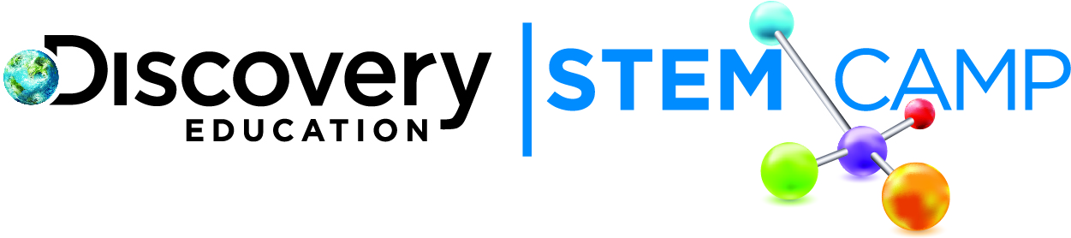

Dear Parents/Guardians,

At Discovery STEM Camp we concluded our STEM-tastic week of exploring water by looking at Your Effect on Water. Here are some highlights from today:
- Examined water contamination
- Studied the effects of pollution on the water supply
- Created water pollution paperslide videos
- Completed the water in fruit experiment

The day began with a water contamination demonstration. Ask your child what he/she learned about contaminants from this activity and how his/her thoughts might have changed about water quality now. We then expanded on this concept by having students construct a model representing how human activity affects a watershed. Ask your child what was learned about how humans affect a watershed ecosystem and what should be done to limit human impact.

We then returned to our water in fruits project and finished graphing the amount of water contained in a variety of fruits. Ask your child what surprised him/her most about the results. Have your child tell you how much water can be consumed by eating fruit.
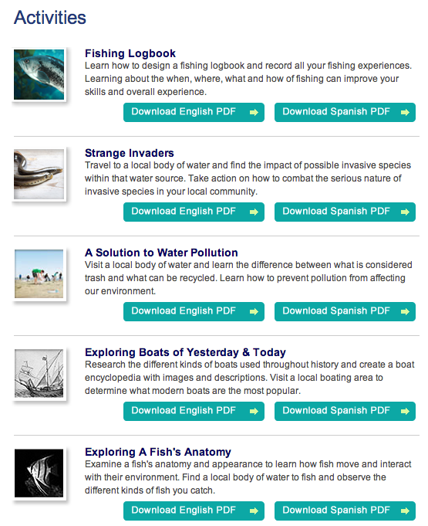
We encourage you to keep exploring the concept of water at http://exploretheblue.discoveryeducation.com. Click on “Family Connection” for a rich variety of activities to help you spend time together with your child outside and explore all that nature has to offer.
We enjoyed having your child with us each day this week and hope that he/she continues to explore the wonderful world of water!

Thank you,

Discovery Education STEM Camp

