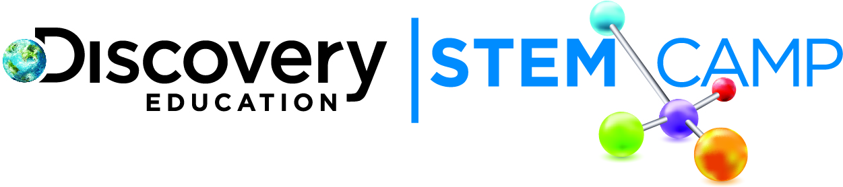

Dear Parents/Guardians,

The first day of Discovery Education STEM Camp was STEM-tastic! Today’s topic was H₂0 and You. We developed an understanding for how important water is for all living things, as well as why it is important to drink water every day.

Here are some of today’s highlights:
- Investigated how much of our bodies are made of water
- Launched a week-long investigation to discover how much water different fruits contain
- Engineered a custom device to transport water over a distance
For the investigation to discover how much water different fruits contain, students began by making predictions on the water content of a variety of fruits. Students measured and recorded the initial weights of fruits and will continue to weigh the fruit each day to determine how much weight is lost by evaporation throughout the week. Check back with your child each day to learn the results.
Our first Engineering Challenge built on the importance of water for all living things and required students to engineer a device to transport water over a distance. Have your child explain what the challenge required and describe his/her solution.

Continue to explore more about H₂0 and You using these helpful links:
- Discover Water - http://www.discoverwater.org/
- Explore the sugar content in drinks - http://goo.gl/6wh6B
- Learn how soda is made - http://goo.gl/FdQRB

We look forward to seeing your child tomorrow as we explore the properties of water!

Thank you,
Discovery Education STEM Camp

