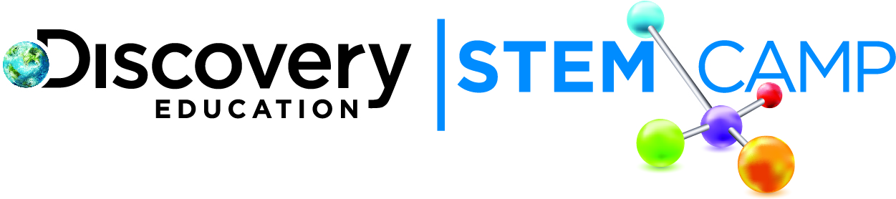

Dear Parents/Guardians,
We had another exciting day at Discovery Education STEM Camp. Today was full of great activities and learning focused on gaining a better understanding of the Properties of Water. Highlights from today include:
- Investigated cohesion and surface tension of water
- Built a virtual ship to learn the principles of buoyancy
- Engineered a boat to transport a weight across a pool

In the cohesion and surface tension activity, students determined the volume of one drop of water and then determined how many drops can fit on a coin. See if your student can tell you the volume of water that can fit on a single coin. Have your student explain the next part of the experiment and what role cohesion played in the experiment.

For today’s Engineering Challenge students were challenged to construct a boat that would float across a small pool carrying a weight. Have your child explain the requirements of the challenge and describe his/her solution. Ask what your child what might have been done differently after seeing how the other teams addressed the Engineering Challenge.

Continue to explore more about Properties of Water using these helpful links.
- Water properties quiz - http://goo.gl/zUvBW
- Fun interactive on buoyancy - http://goo.gl/QVQFa

We look forward to seeing your child tomorrow as we learn about water in ecosystems!

Thank you,

Discovery Education STEM Camp

