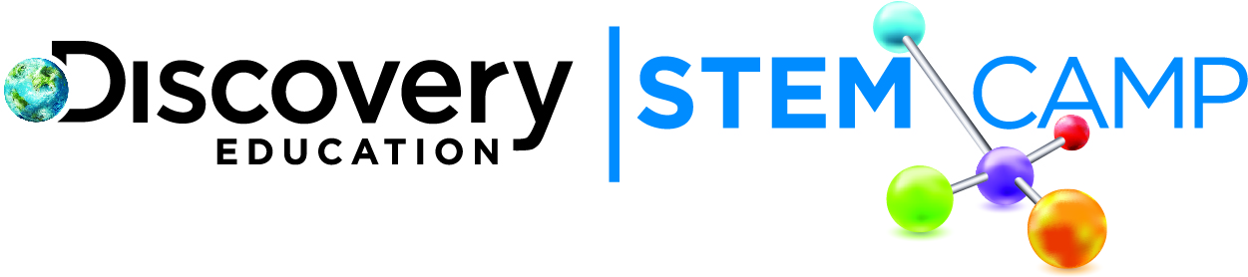

Dear Parents/Guardians,

The first day of Discovery Education STEM Camp was STEM-tastic! Today’s topic was Energy and You. We developed an understanding several different forms of energy, as well as how one form of energy can be transformed into another and how transformations of energy can be used to generate electricity.
Here are some of today’s highlights:
- Explored different conversions of potential to kinetic energy
- Built a simple circuit that included a light bulb
- Participated in an Engineering Challenge to design and build a simple machine using a marble and a series of chain reactions to turn on a light bulb

As the week progresses, we will learn about different fuels for producing energy. We will also be looking at the challenges of using some of these fuels as well as several current ideas for alternative fuels. Check in with your student over the course of the week as they learn more about ways to generate energy for our use.

Continue to explore more about Energy and You with these helpful links:
- Forms of energy - http://www.eia.gov/kids/energy.cfm?page=about_forms_of_energy-basics
- Nonrenewable and renewable energy sources - http://www.ck12.org/earth-science/Renewable-vs-Non-Renewable-Energy-Resources/
- Learn how about simple circuits and diagrams - http://tinyurl.com/mwe543g

We look forward to seeing your child tomorrow as we explore nonrenewable, and renewable energy resources!

Thank you,
Discovery Education STEM Camp

